<iframe src="https://data.worldbank.org/share/widget?end=2025&indicators=NY.GDP.MKTP.CD&locations=KE&start=2016&view=chart" width='450' height='300' frameBorder='0' scrolling="no" ></iframe>

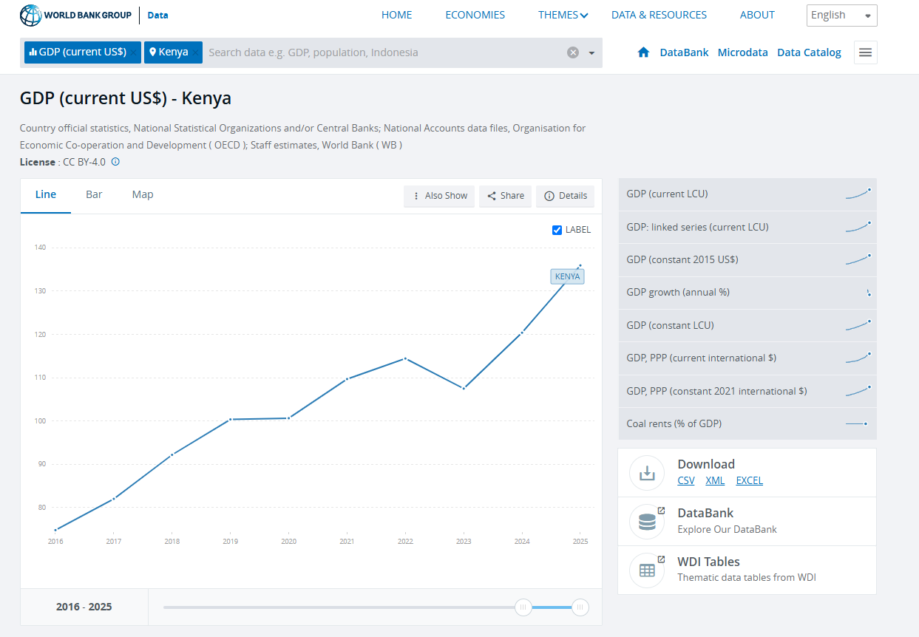

https://data.worldbank.org/indicator/NY.GDP.MKTP.CD?end=2025&locations=KE&start=2016&view=chart

https://www.ibge.gov.br/estatisticas/economicas/contas-nacionais/9088-produto-interno-bruto-dos-municipios.html?t=downloads&c=3543402

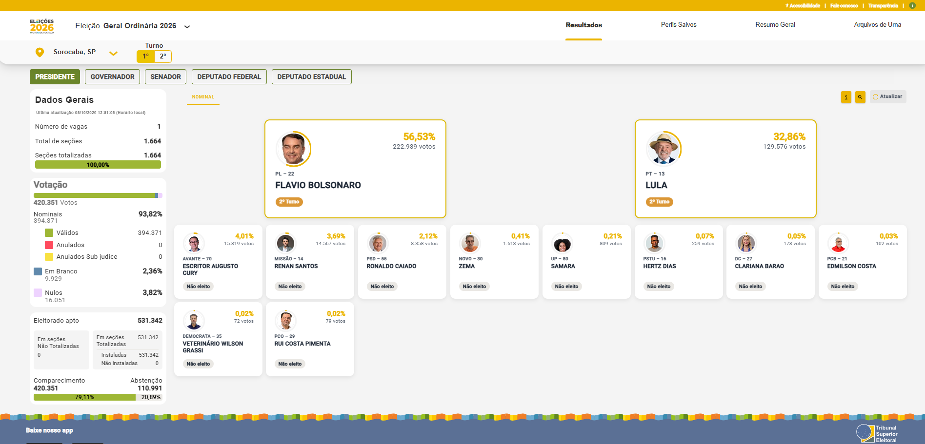

https://resultados.tse.jus.br/oficial/app/index.html#/eleicao/6257/uf/sp/mu/71455/cargo/1/vis/nominal/resultados

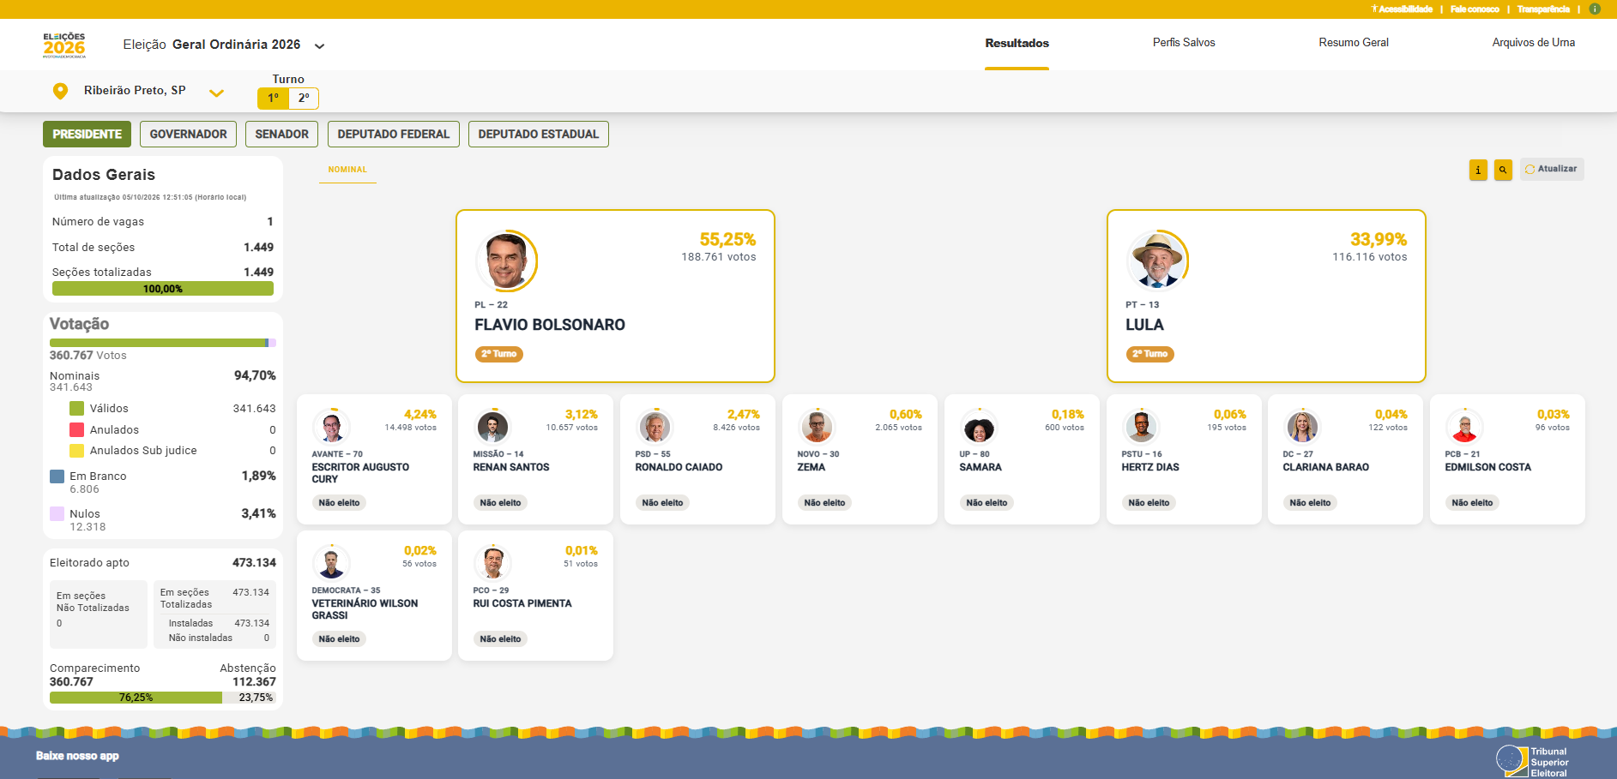

https://resultados.tse.jus.br/oficial/app/index.html#/eleicao/6257/uf/sp/mu/69698/cargo/1/vis/nominal/resultados

